Reading Tasks:

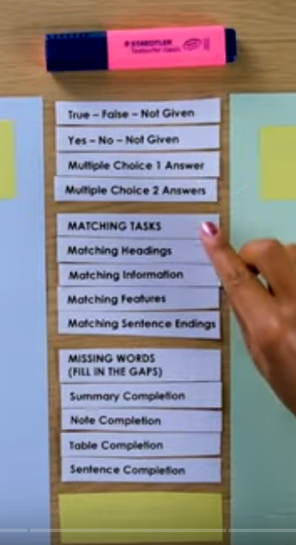

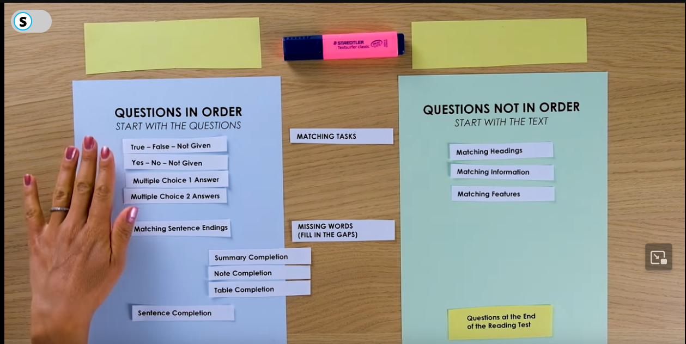

# Questions In Order Strategy:

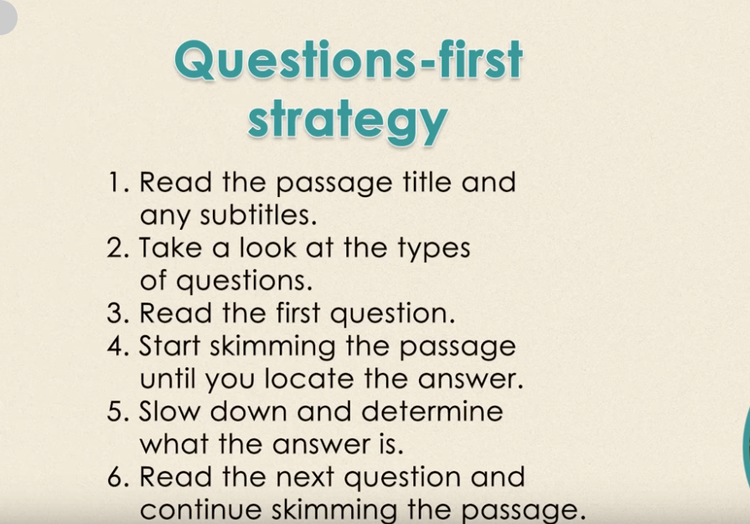

1st Passage is easier

2nd Passage is hard

3rd Passage is harder

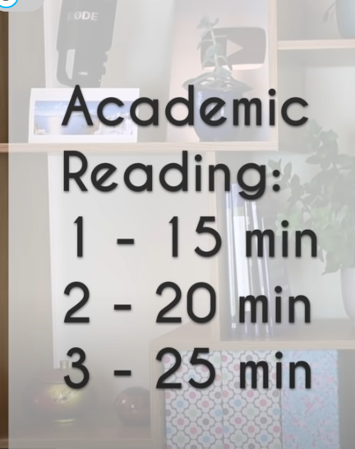

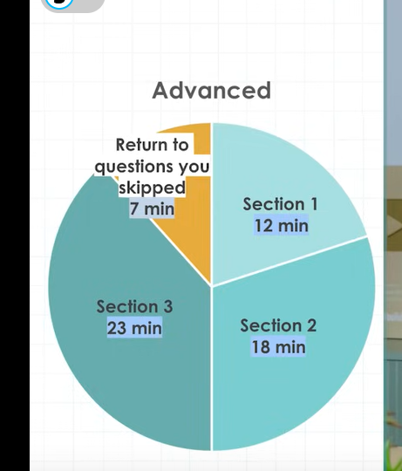

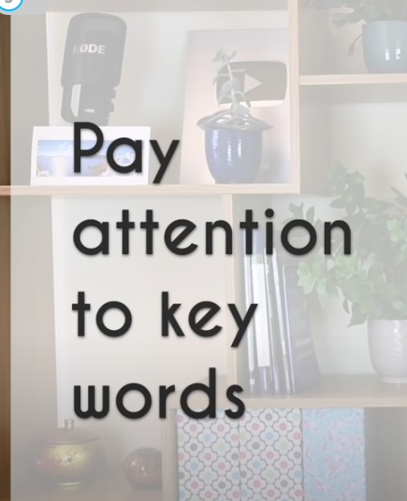

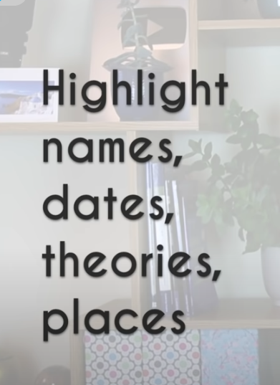

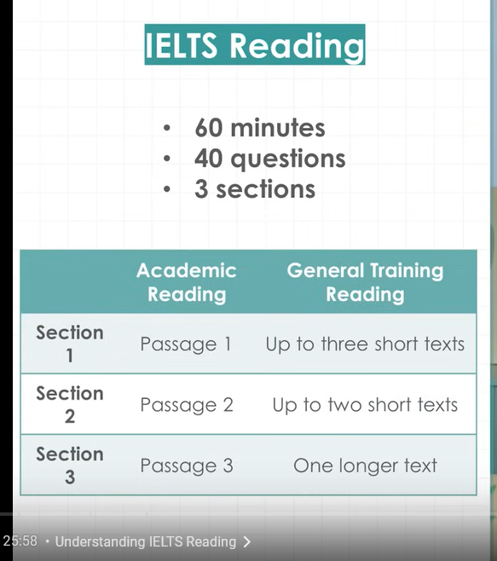

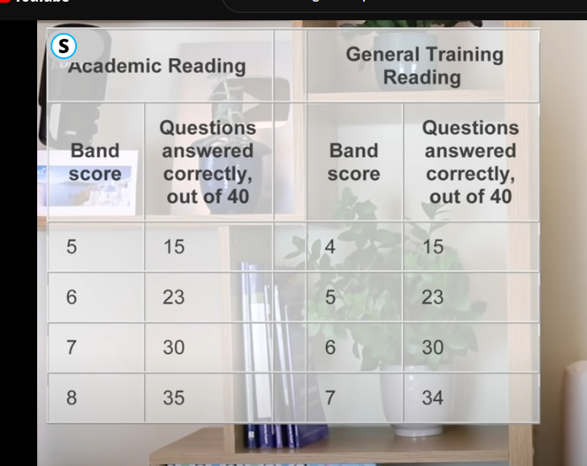

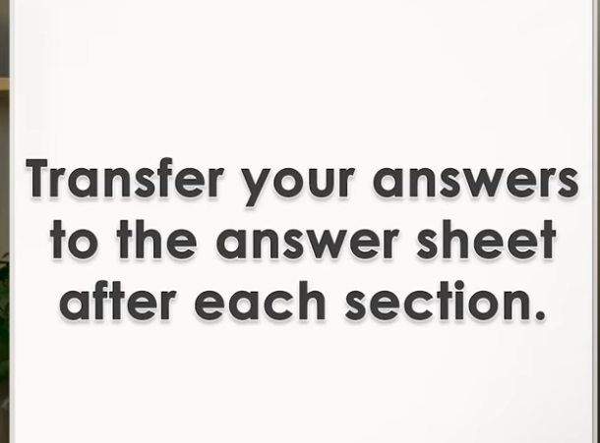

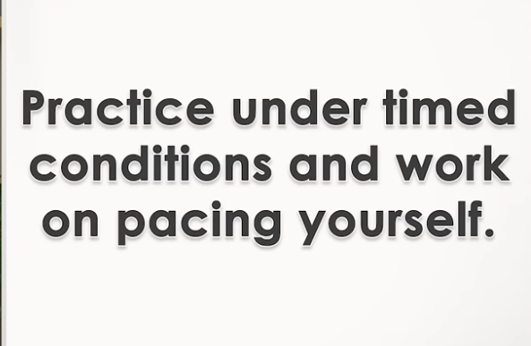

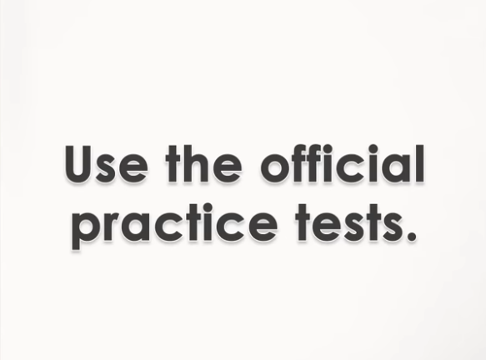

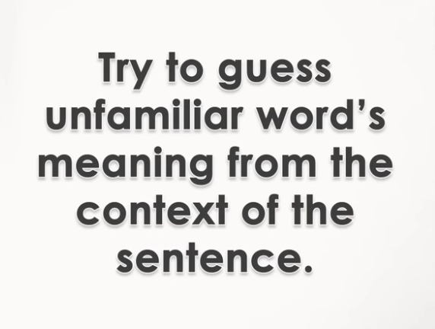

Strategies for Answering Questions:

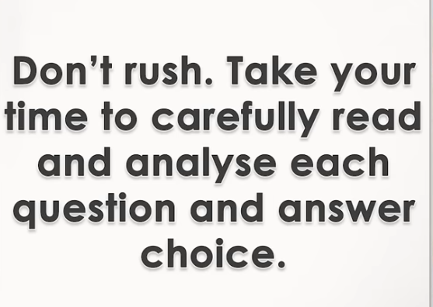

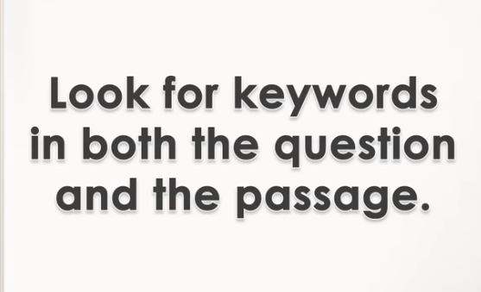

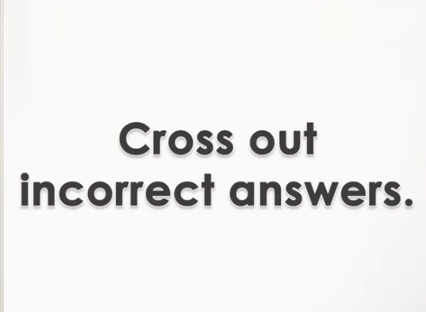



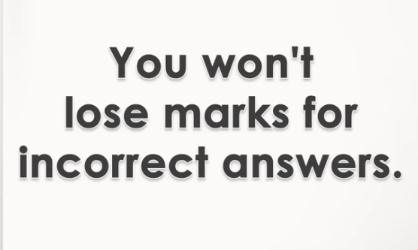

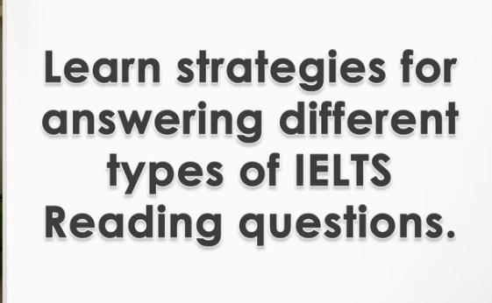

# True False Not Given Questions:

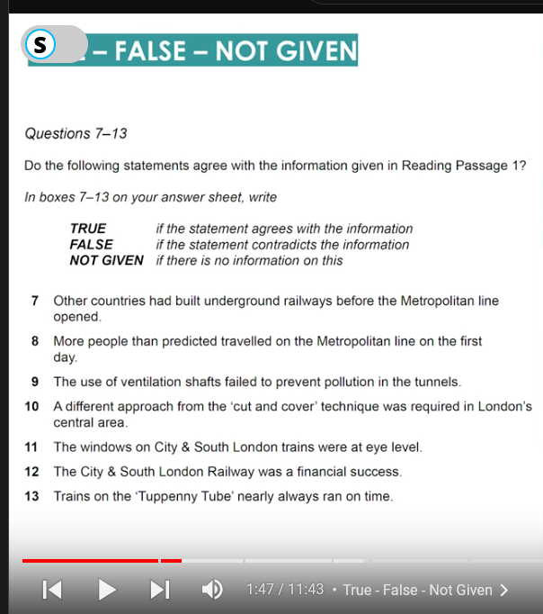–

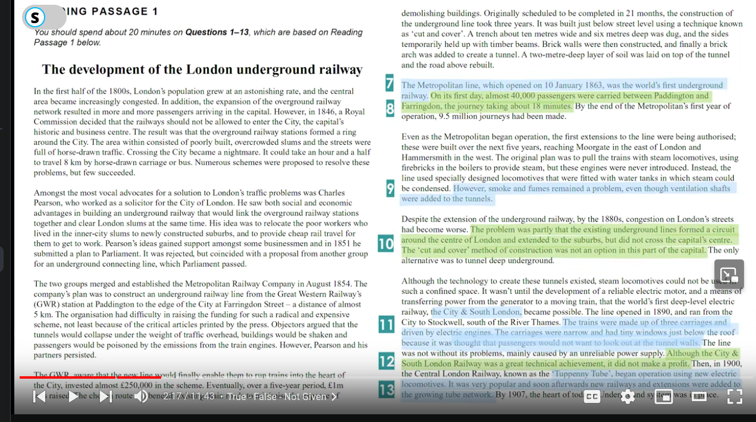

7. False 8. True 9. True 10. True 11. Not Given 12. False 13. Not Given

Yes – No – Not Given:

* More about opinions and less about facts
* We need fully understand someone’s opinion
* Can’t be bias to our own opinions think neutrally

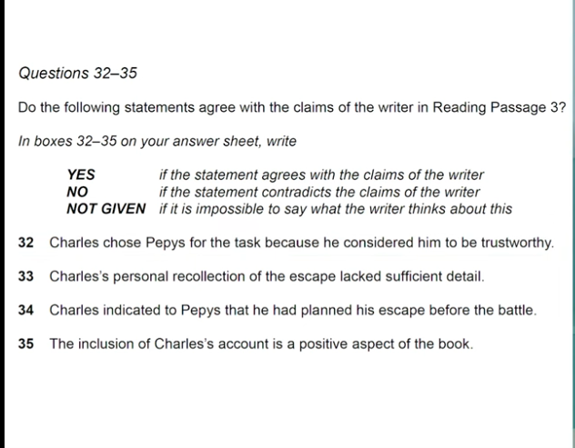

# Multiple Choice Questions:

Paragraphs are mentioned

Most probably choosing 1 option questions are in order

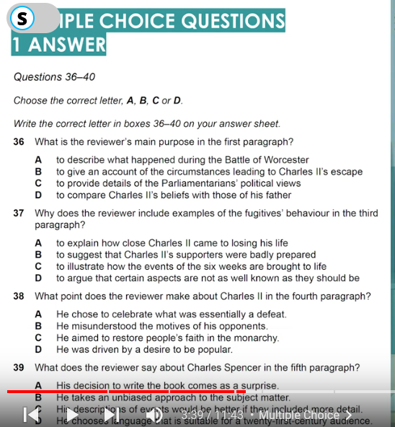

But choosing 2 options questions are not in order

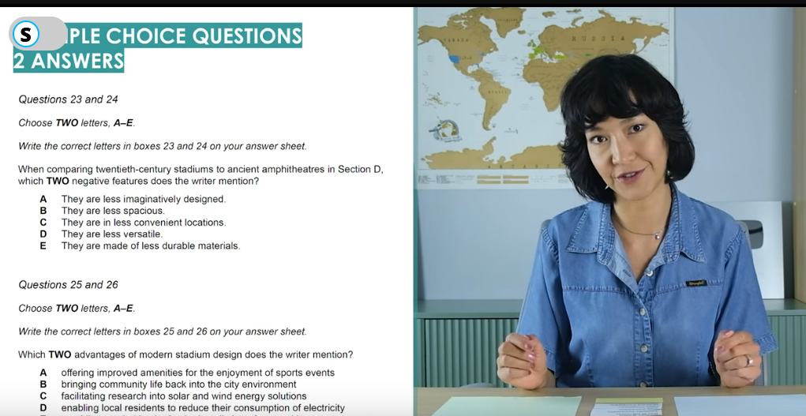

# Matching Headings:

Read the paragraph and then start match the headings as this is unordered.

Do this in 1 go and then start matching those paragraphs you couldn’t match.

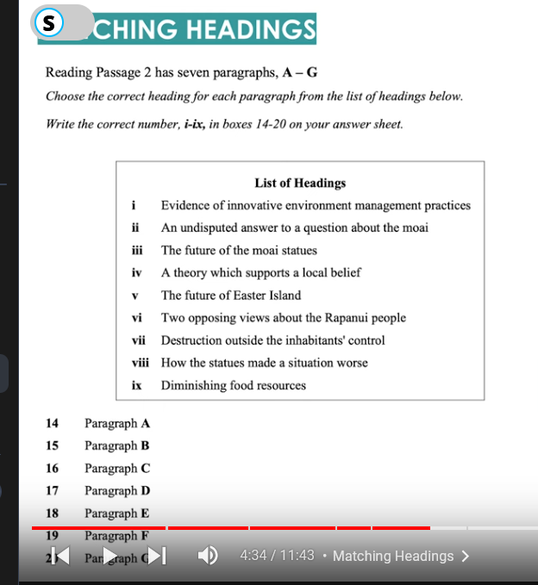

Matching Information:

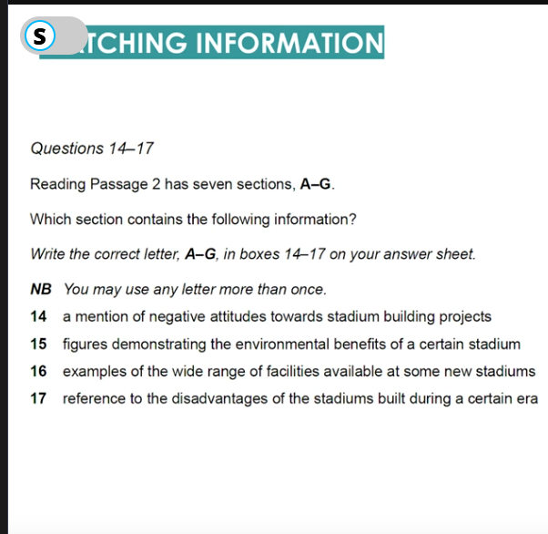

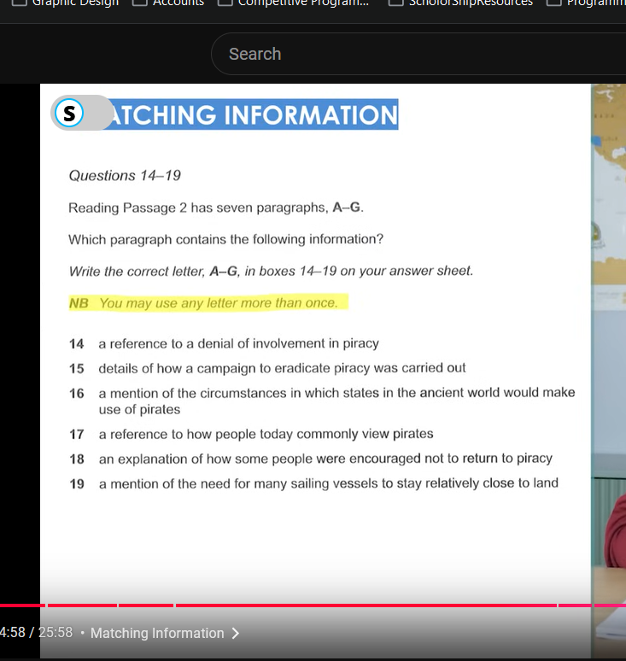

1 section contains 2 answers or more

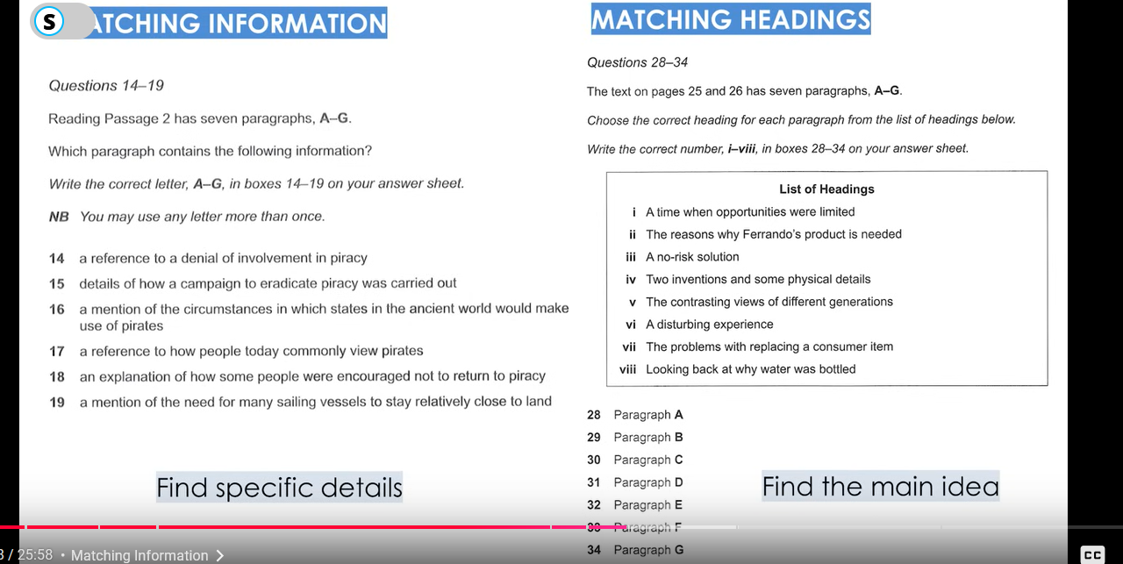

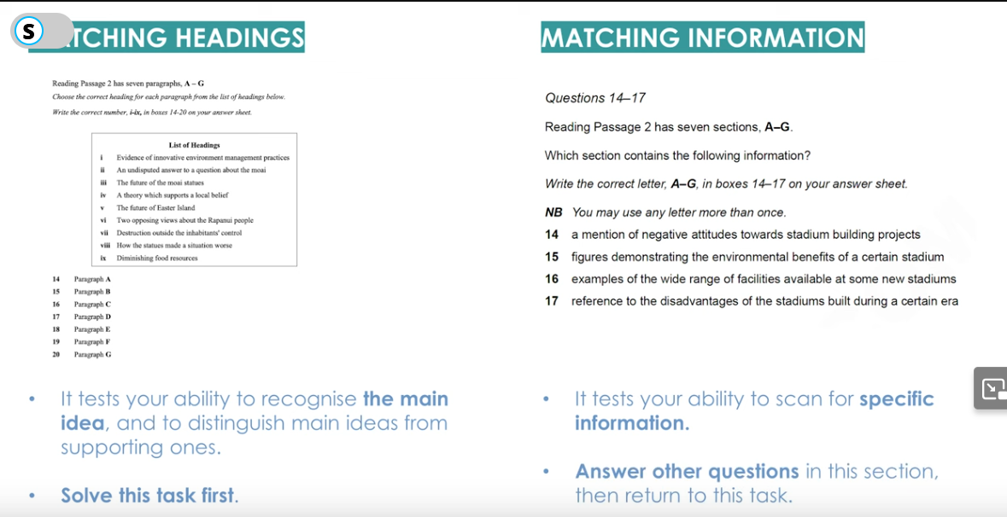

# Matching Features:

* First highlight the listed features quickly and then bind the features.

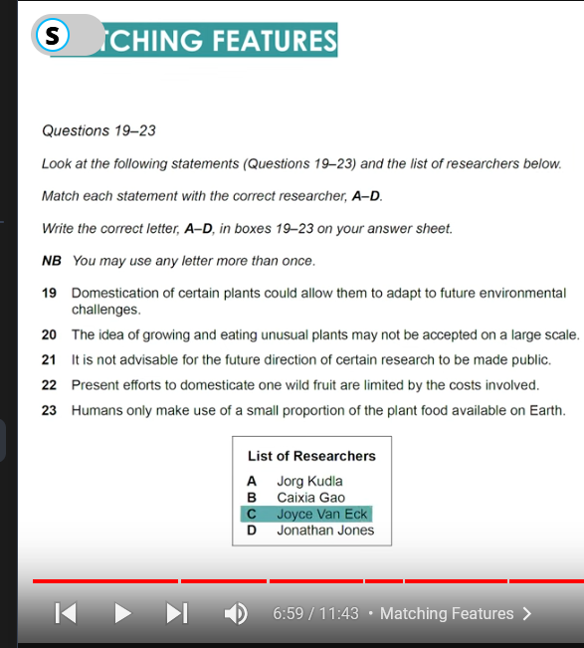

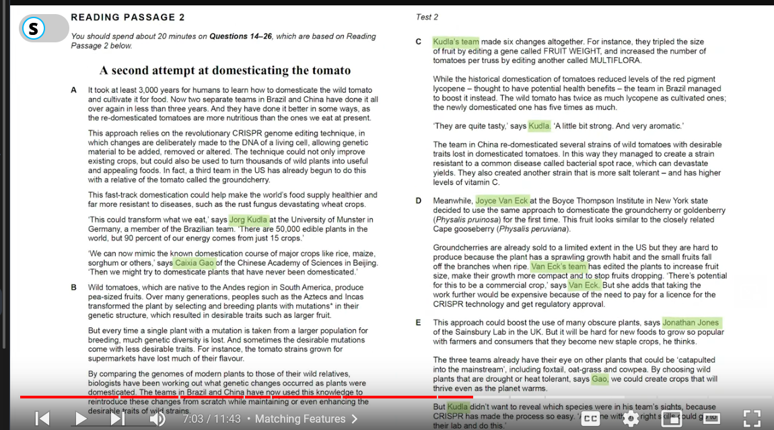

1. Jorg Kudla -> 23, 21. 2. Joyce Van Eck -> 22 3. Jonathon Jones -> 20. 4. Caixia Gao -> 19

# Matching Endings:

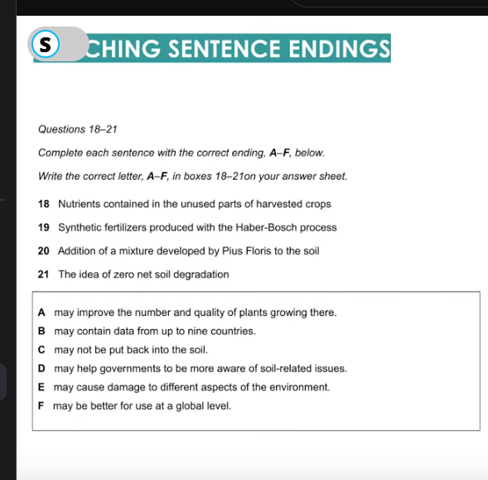

# Summary/Note/Table Completion | Missing Words:

Can or Cannot occur in order but most of them do come in order.

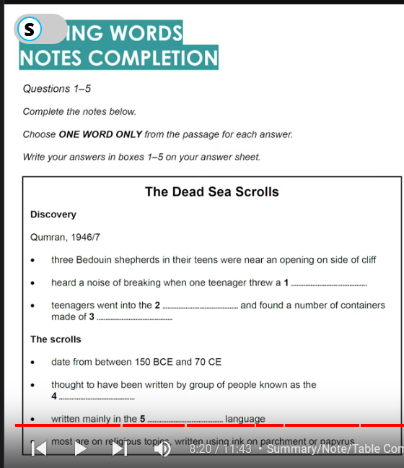

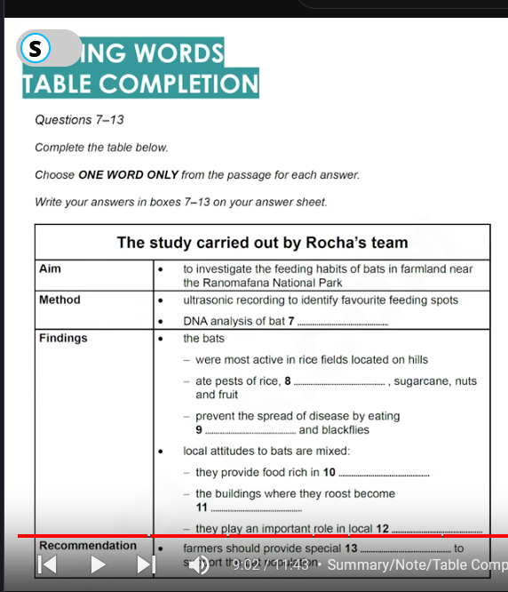

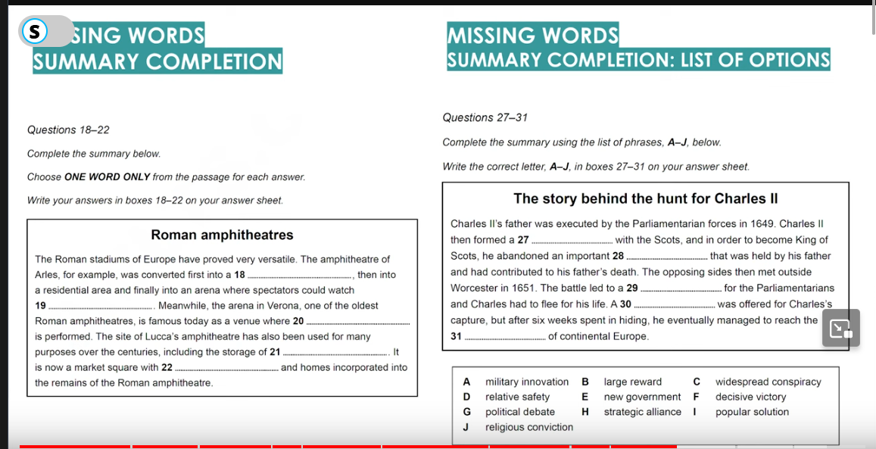

27 -> E, 28 -> G, 29 -> F, 30 -> B, 31 -> D

# Sentence Completion | Missing Words:

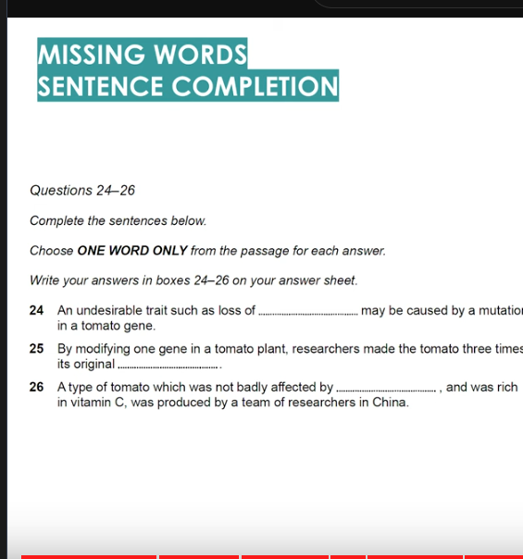

* 24 -> Flavour, 25 -> size, 26 -> Bacterial Spot Race

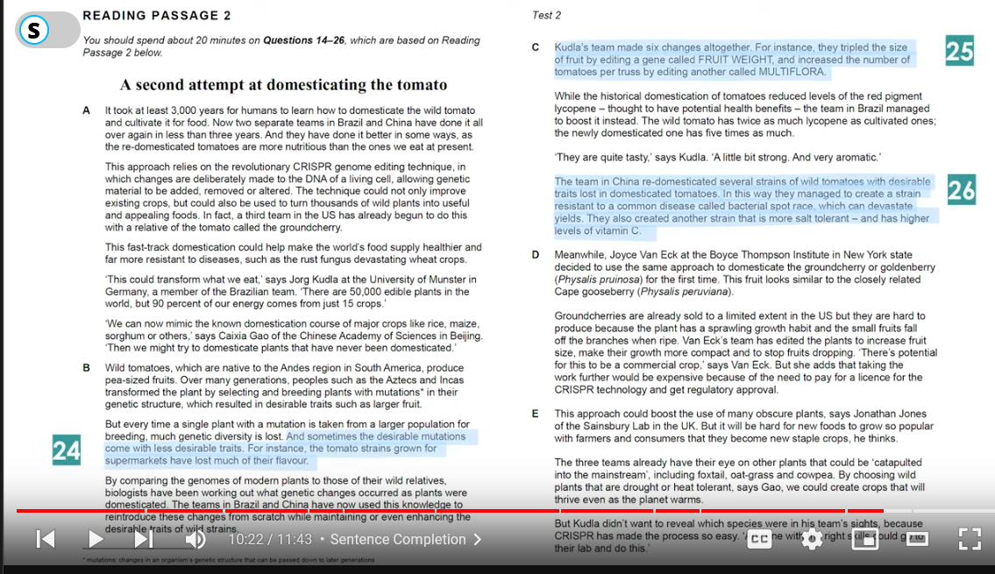

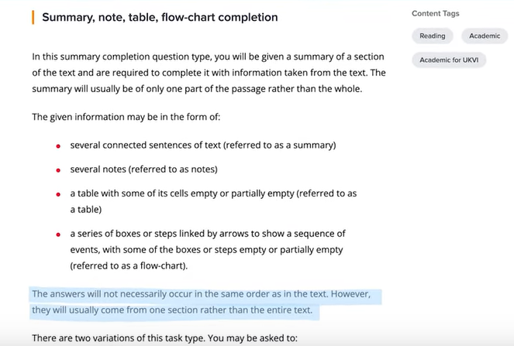

* They may usually come from only 1 section/paragraph
* 40 questions -> 3 longer
* I would say Read x3 questions first then start skimming through the paragraphs and when you feel you reached a point where the answer is somewhere hidden its time to slow down the pace.
* Read the question and highlight the keywords and what do they mean, look for the keywords synonyms in the paragraph
* Ignore irrelevant content that doesn’t relate with the keywords
* Most of the questions order follow the passage

# True – False – Not Given

* There must be all 3 types of answers used in this exam

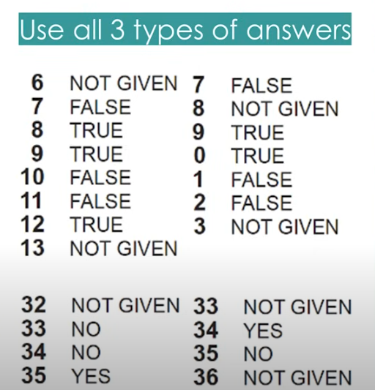

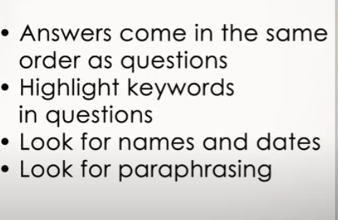

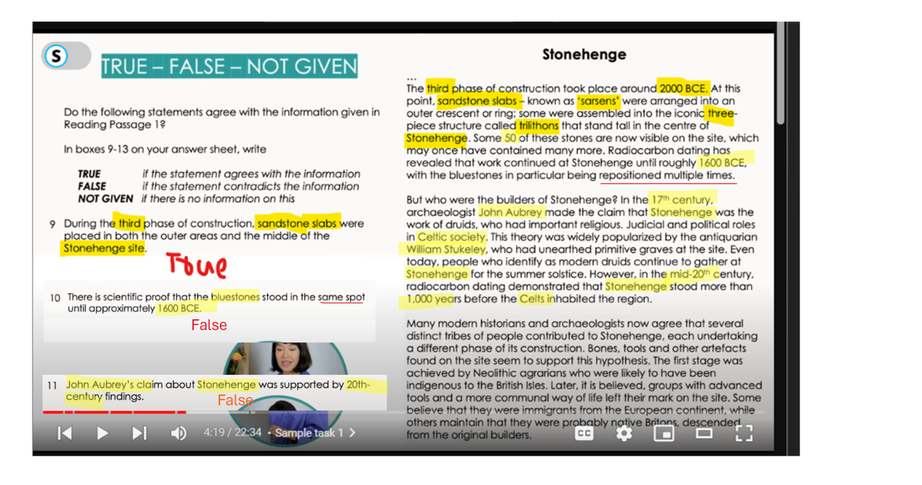

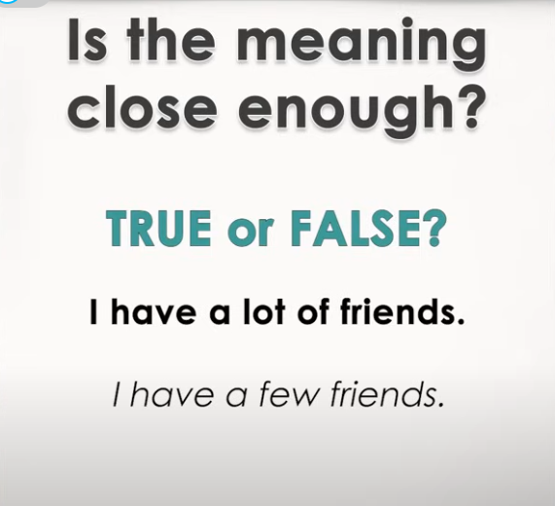

# IELTS Reading Practice:

## Yes – No – Not Given Questions:

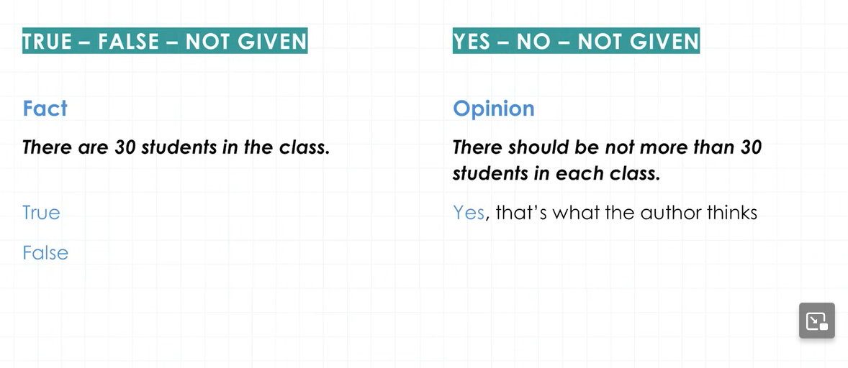

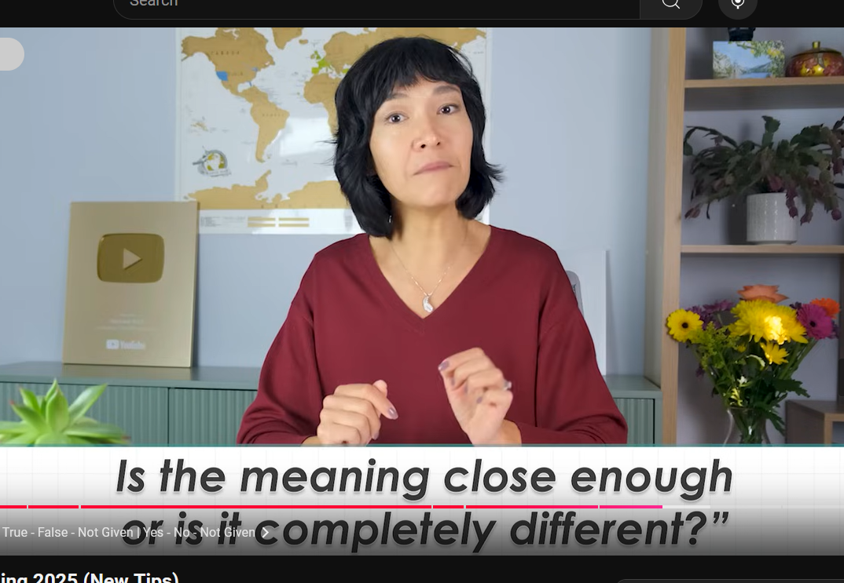

If Close then Yes if completely different then No

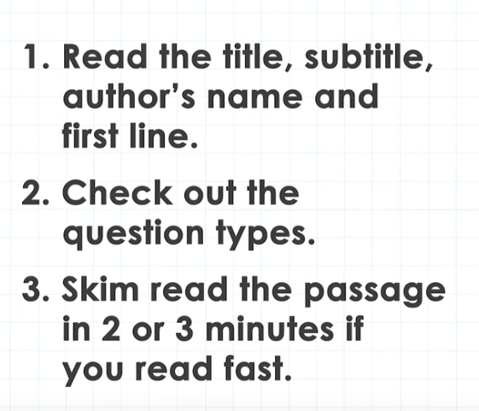

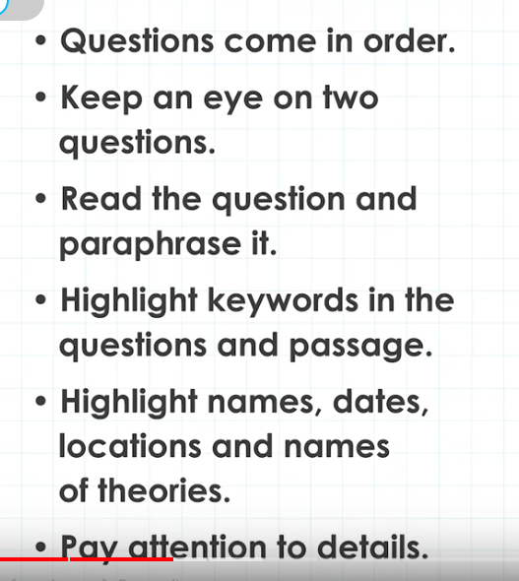

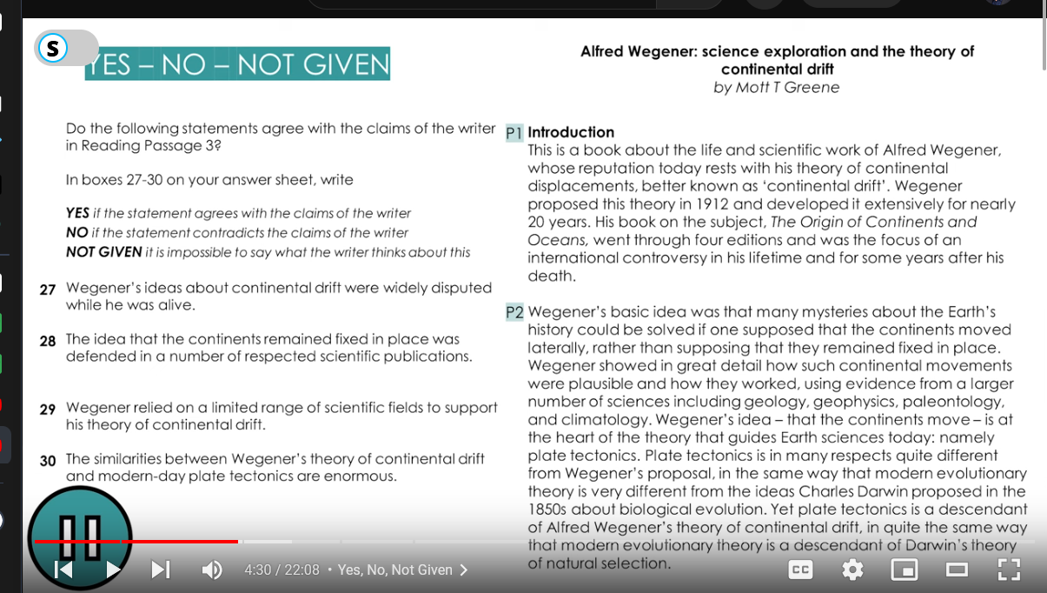

## Summary Completion:

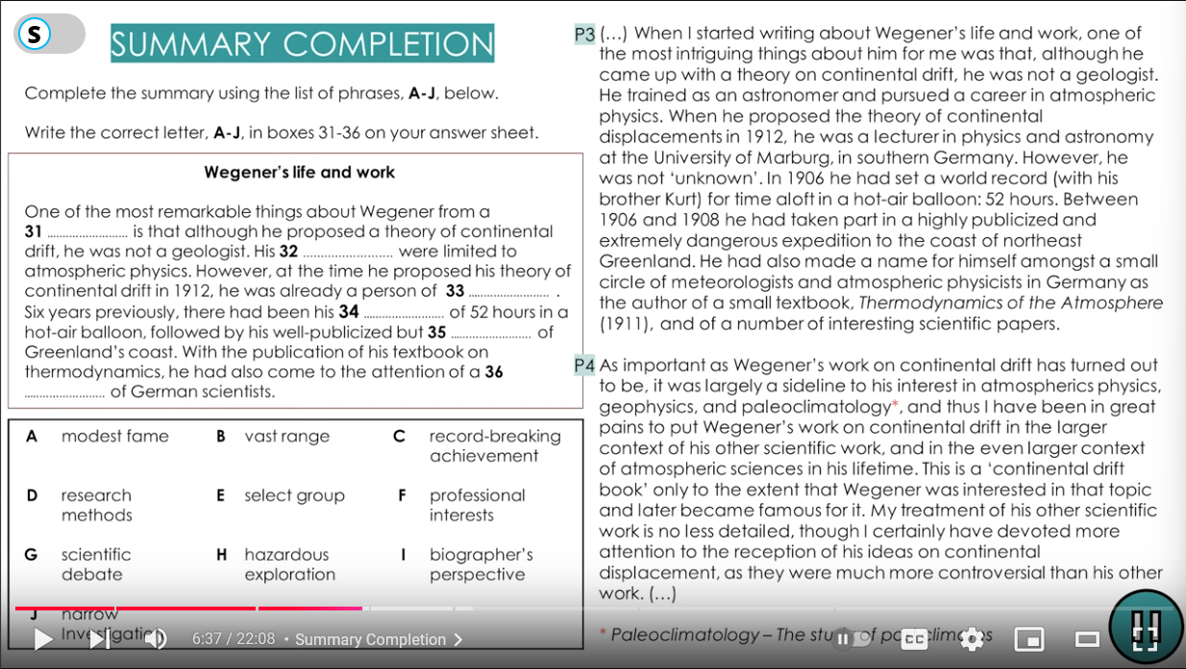

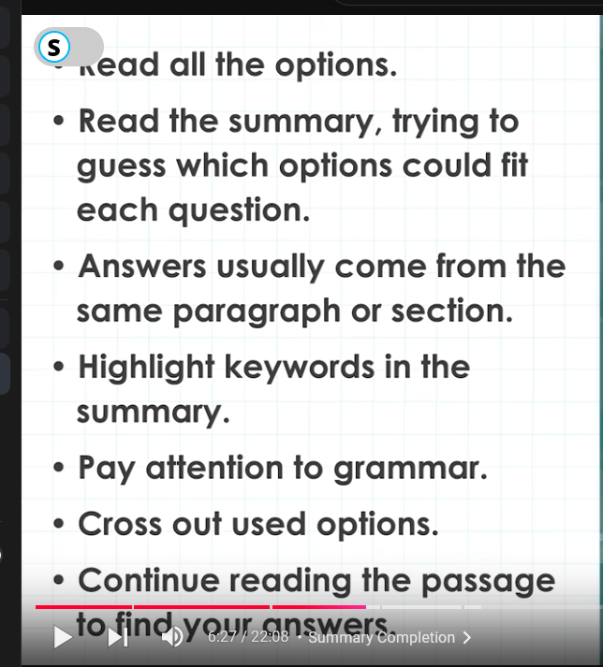

## Multiple Choice Questions:

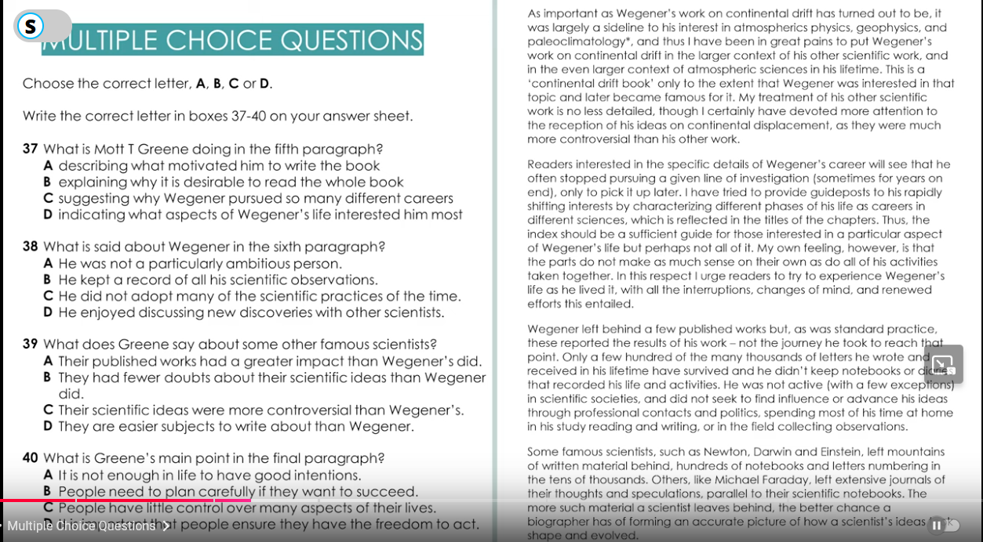

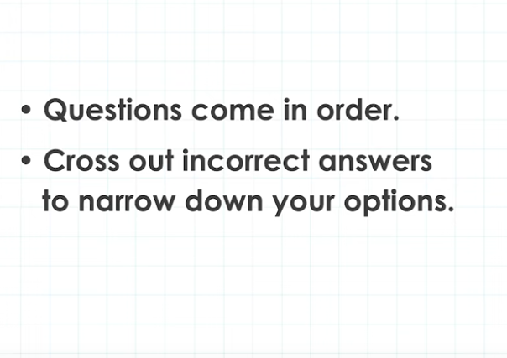

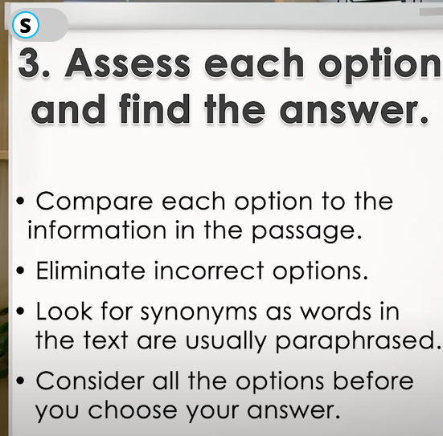

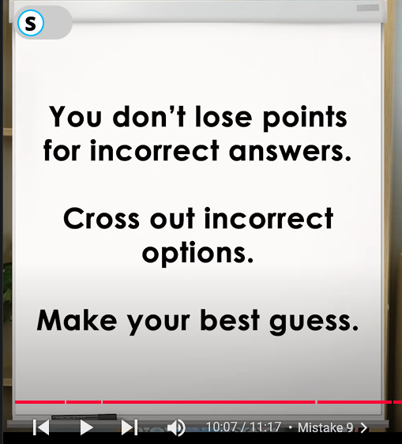

## Matching Information:

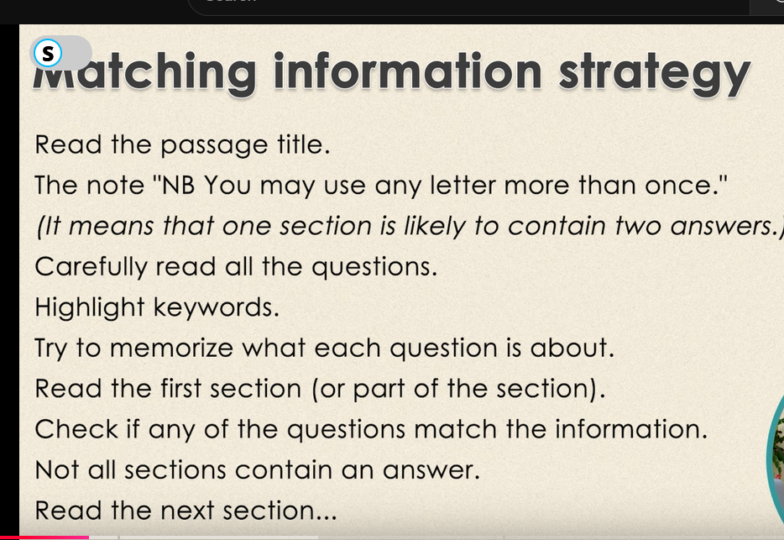

## Matching Features:

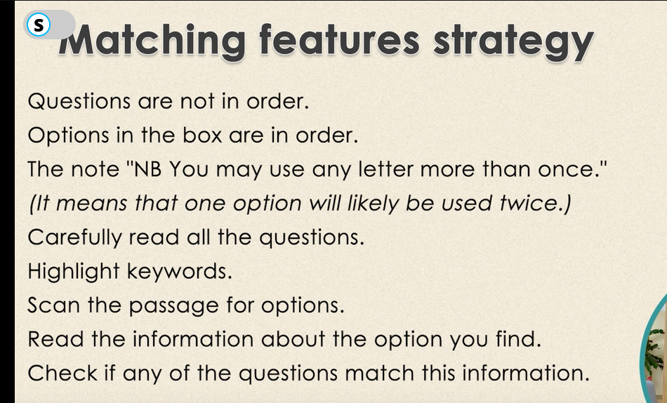

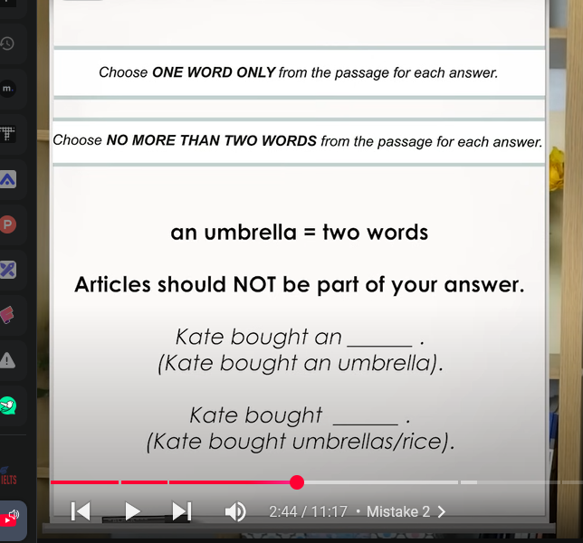

# IELTs Reading Speed Enhancement Shortcut:

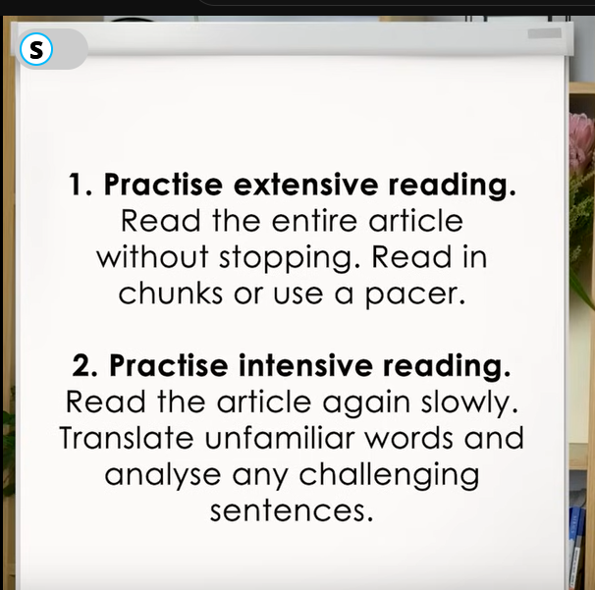

* Highlight information like Name(persons, things, organization etc), Title, Dates, Quotes, Fact/Information.

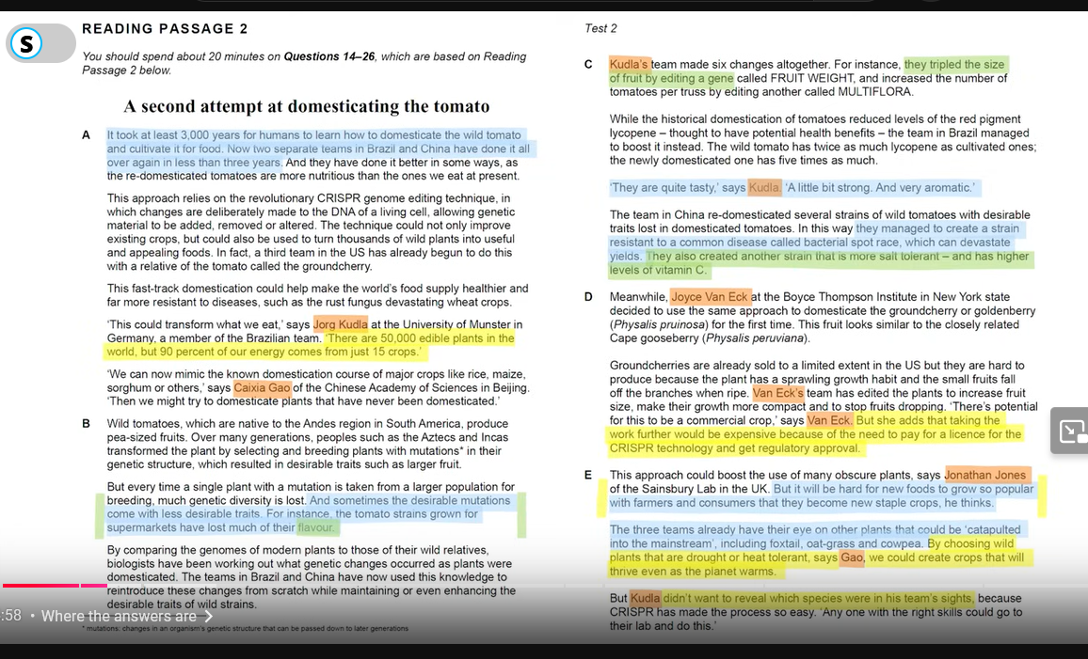

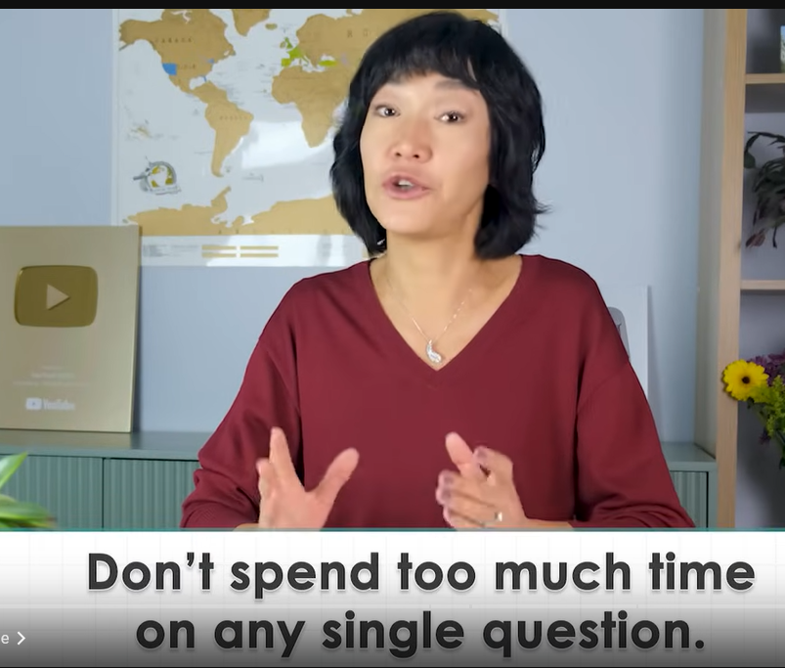

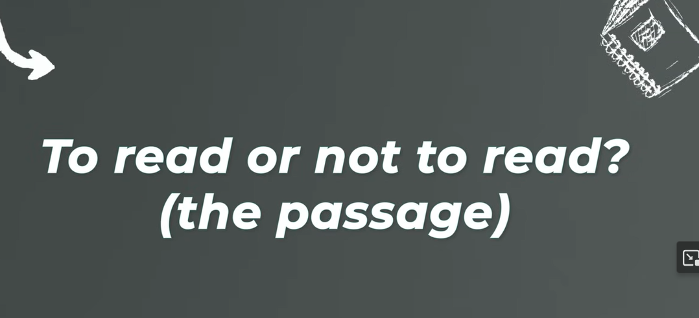

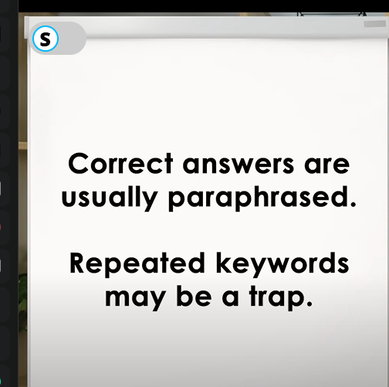

# Overall Practice With Strategy Revision:

https://youtu.be/BQbXC22Yujc?si=DUlHPSGkWwm4Ogdk